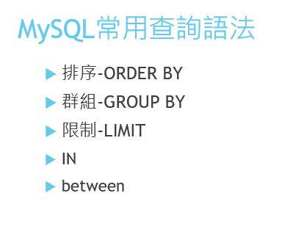

[SELECT](http://localhost/phpmyadmin/url.php?url=https://dev.mysql.com/doc/refman/5.5/en/select.html) * FROM `students` ORDER BY 學號 DESC

[SELECT](http://localhost/phpmyadmin/url.php?url=https://dev.mysql.com/doc/refman/5.5/en/select.html) [count](http://localhost/phpmyadmin/url.php?url=https://dev.mysql.com/doc/refman/5.5/en/group-by-functions.html#function_count)(*) FROM `students` where substr(班級座號,1,3)

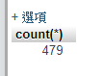

[SELECT](http://localhost/phpmyadmin/url.php?url=https://dev.mysql.com/doc/refman/5.5/en/select.html) [count](http://localhost/phpmyadmin/url.php?url=https://dev.mysql.com/doc/refman/5.5/en/group-by-functions.html#function_count)(*) FROM `students` where substr(班級座號,1,3) group by substr(班級座號,1,3)

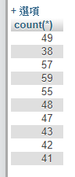

SELECT substr(班級座號,1,3) AS '班級',`科別`,count(*) FROM `students` group by substr(班級座號,1,3),科別

[SELECT](http://localhost/phpmyadmin/url.php?url=https://dev.mysql.com/doc/refman/5.5/en/select.html) substr(班級座號,1,3) AS '班級',`科別`,[count](http://localhost/phpmyadmin/url.php?url=https://dev.mysql.com/doc/refman/5.5/en/group-by-functions.html#function_count)(*) FROM `students` group by substr(班級座號,1,3),科別

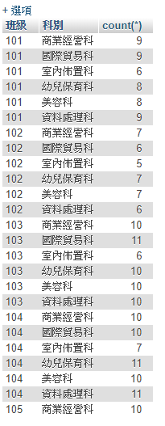



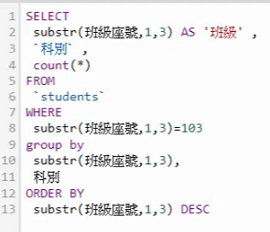

[SELECT](http://localhost/phpmyadmin/url.php?url=https://dev.mysql.com/doc/refman/5.5/en/select.html) substr(班級座號,1,3) AS '班級',`科別`,[count](http://localhost/phpmyadmin/url.php?url=https://dev.mysql.com/doc/refman/5.5/en/group-by-functions.html#function_count)(*) FROM `students` WHERE substr(班級座號,1,3)=103 GROUP BY substr(班級座號,1,3),科別 ORDER BY substr(班級座號,1,3) DESC

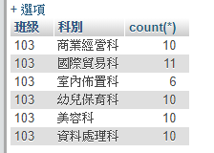

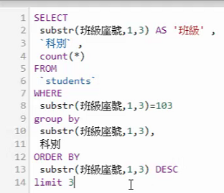

[SELECT](http://localhost/phpmyadmin/url.php?url=https://dev.mysql.com/doc/refman/5.5/en/select.html) substr(班級座號,1,3) AS '班級', `科別`, [count](http://localhost/phpmyadmin/url.php?url=https://dev.mysql.com/doc/refman/5.5/en/group-by-functions.html#function_count)(*) FROM `students` WHERE substr(班級座號,1,3)=103 GROUP BY substr(班級座號,1,3), 科別 ORDER BY substr(班級座號,1,3) DESC LIMIT 3

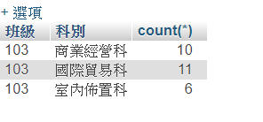



SELECT * FROM `students` WHERE `出生年月日` >='1983-04-01' && `出生年月日` <='1983-04-30'

或

[SELECT](http://localhost/phpmyadmin/url.php?url=https://dev.mysql.com/doc/refman/5.5/en/select.html) * FROM `students` WHERE `出生年月日` BETWEEN '1983-04-01' [AND](http://localhost/phpmyadmin/url.php?url=https://dev.mysql.com/doc/refman/5.5/en/logical-operators.html#operator_and)'1983-04-30'

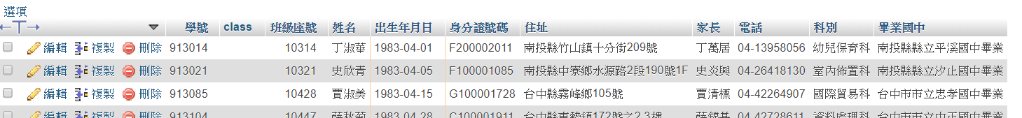



Group 不會用在全部資料

一般會在select 縮範圍

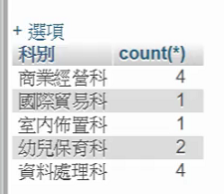



[SELECT](http://localhost/phpmyadmin/url.php?url=https://dev.mysql.com/doc/refman/5.5/en/select.html) * FROM `students` WHERE `學號`=911002 || `學號`=911005

或

[SELECT](http://localhost/phpmyadmin/url.php?url=https://dev.mysql.com/doc/refman/5.5/en/select.html) * FROM `students` WHERE `學號`[IN](http://localhost/phpmyadmin/url.php?url=https://dev.mysql.com/doc/refman/5.5/en/comparison-operators.html#function_in) (911002,911005)

SELECT * FROM `students` WHERE `學號`IN (911002,911005)



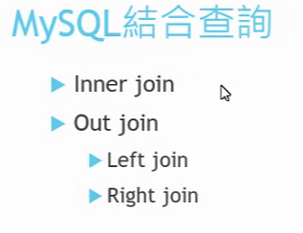

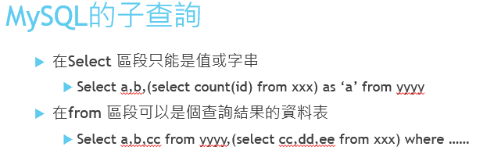



[SELECT](http://localhost/phpmyadmin/url.php?url=https://dev.mysql.com/doc/refman/5.5/en/select.html) `班級座號`,[sum](http://localhost/phpmyadmin/url.php?url=https://dev.mysql.com/doc/refman/5.5/en/group-by-functions.html#function_sum)(`公假`) AS '公假', [sum](http://localhost/phpmyadmin/url.php?url=https://dev.mysql.com/doc/refman/5.5/en/group-by-functions.html#function_sum)(`事假`) AS '事假',[sum](http://localhost/phpmyadmin/url.php?url=https://dev.mysql.com/doc/refman/5.5/en/group-by-functions.html#function_sum)(`病假`) AS '病假',[sum](http://localhost/phpmyadmin/url.php?url=https://dev.mysql.com/doc/refman/5.5/en/group-by-functions.html#function_sum)(`曠課`) AS '曠課' FROM records GROUP BY `班級座號`

SELECT `班級座號`,sum(`公假`) AS '公假', sum(`事假`) AS '事假',sum(`病假`) AS '病假',sum(`曠課`) AS '曠課' FROM records GROUP BY `班級座號`

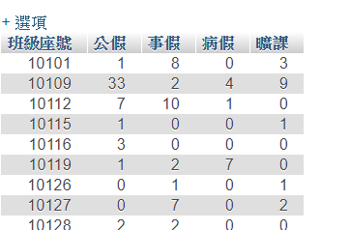







 依左邊students為主

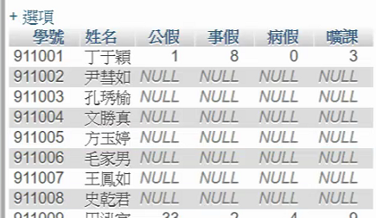

 依右邊這張表records為主



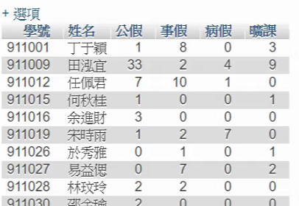

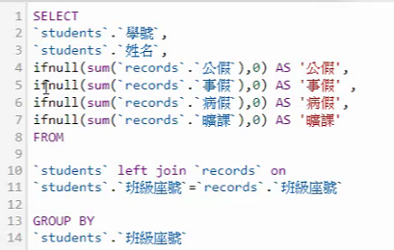

ifnull 的用法

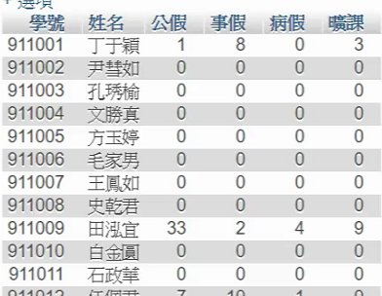

SELECT `業務姓名`,SUM(`數量`) FROM `sales` WHERE `交易年`=88 GROUP BY `業務姓名`

[SELECT](http://localhost/phpmyadmin/url.php?url=https://dev.mysql.com/doc/refman/5.5/en/select.html) `業務姓名`,[SUM](http://localhost/phpmyadmin/url.php?url=https://dev.mysql.com/doc/refman/5.5/en/group-by-functions.html#function_sum)(`數量`) FROM `sales` WHERE `交易年`=88 GROUP BY `業務姓名`

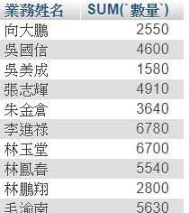

SELECT `業務姓名`,SUM(`數量`)/(SELECT sum(`數量`)FROM `sales`) AS '百分比' FROM `sales` WHERE `交易年`=88 GROUP BY `業務姓名`

[SELECT](http://localhost/phpmyadmin/url.php?url=https://dev.mysql.com/doc/refman/5.5/en/select.html) `業務姓名`,[SUM](http://localhost/phpmyadmin/url.php?url=https://dev.mysql.com/doc/refman/5.5/en/group-by-functions.html#function_sum)(`數量`)/([SELECT](http://localhost/phpmyadmin/url.php?url=https://dev.mysql.com/doc/refman/5.5/en/select.html) [sum](http://localhost/phpmyadmin/url.php?url=https://dev.mysql.com/doc/refman/5.5/en/group-by-functions.html#function_sum)(`數量`)FROM `sales`) AS '百分比' FROM `sales` WHERE `交易年`=88 GROUP BY `業務姓名`

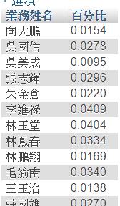

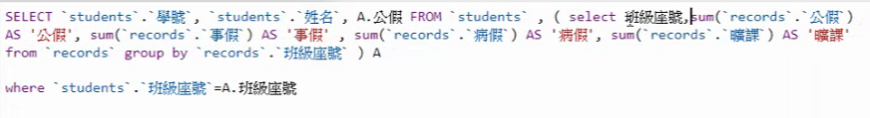

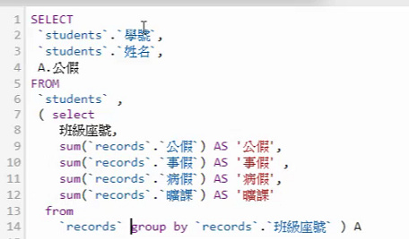

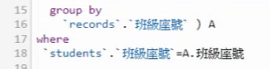

Left join on 用法

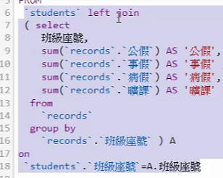

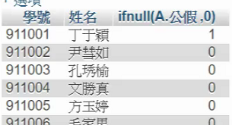





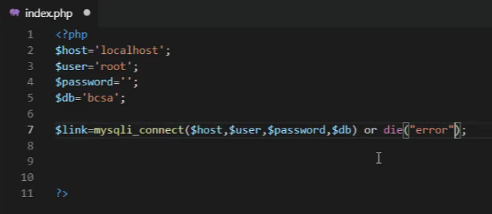

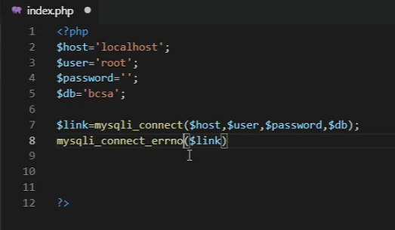

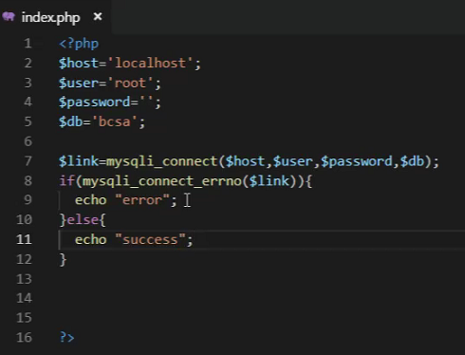

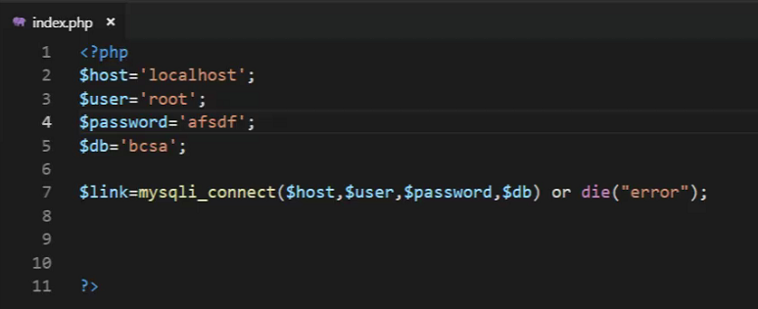



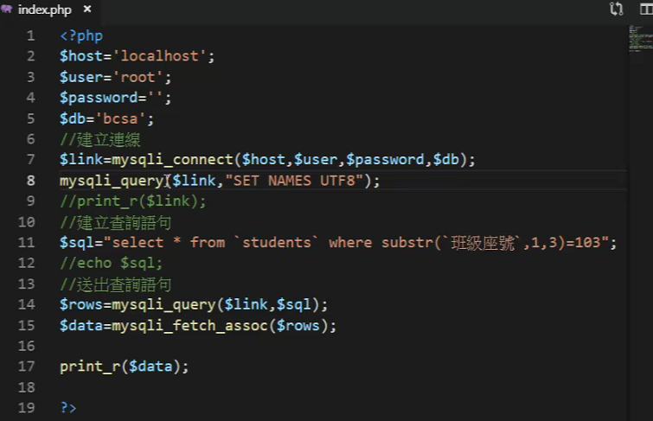

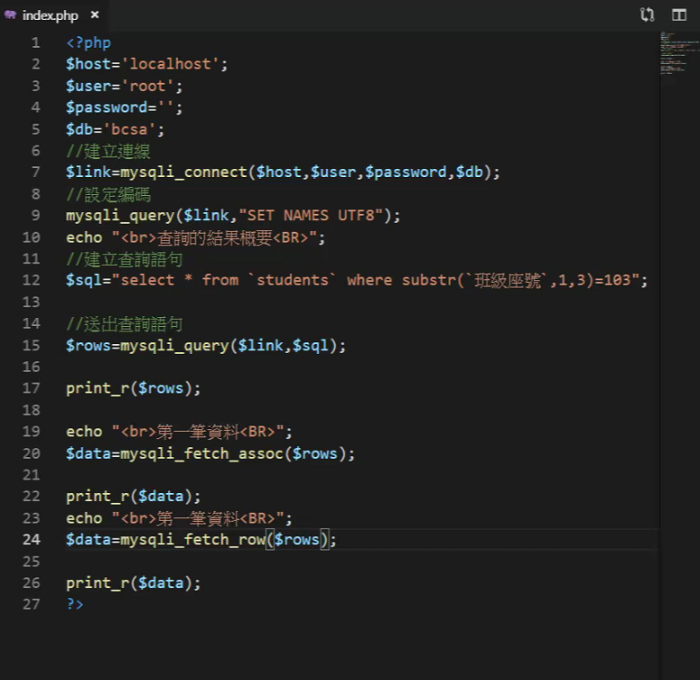

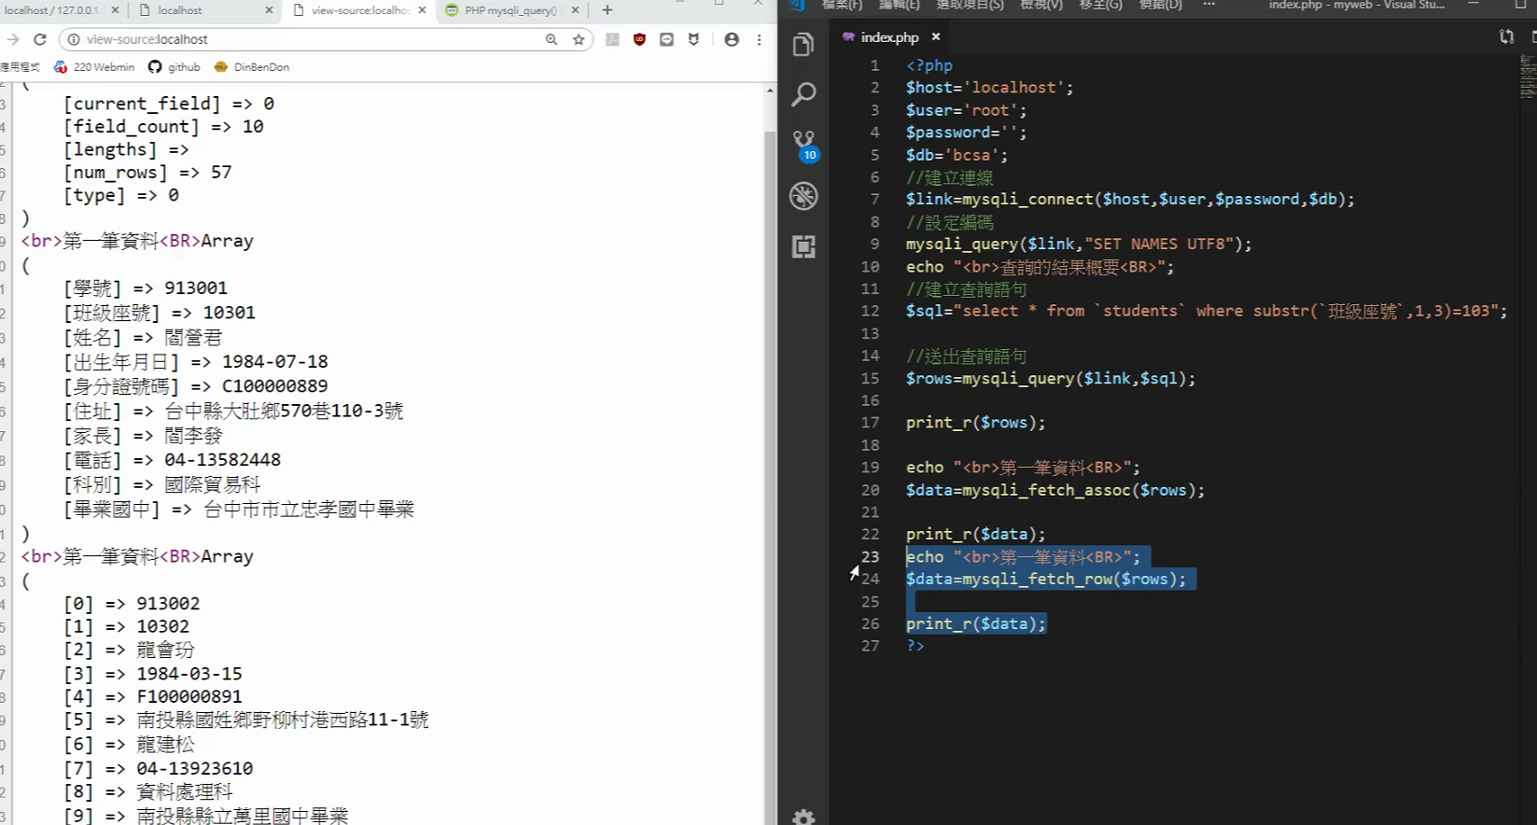

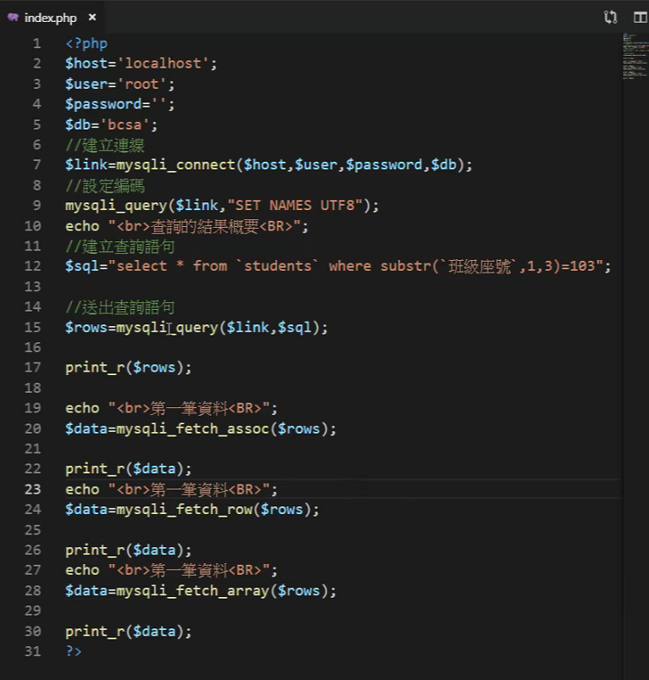

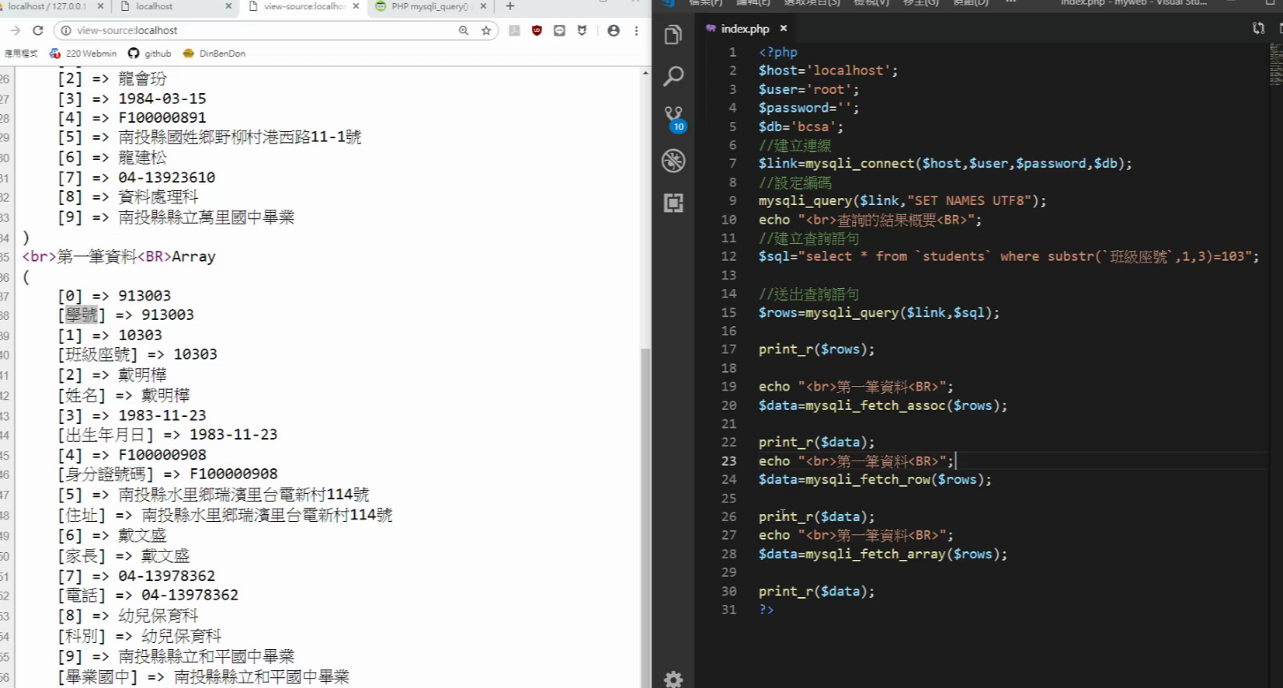

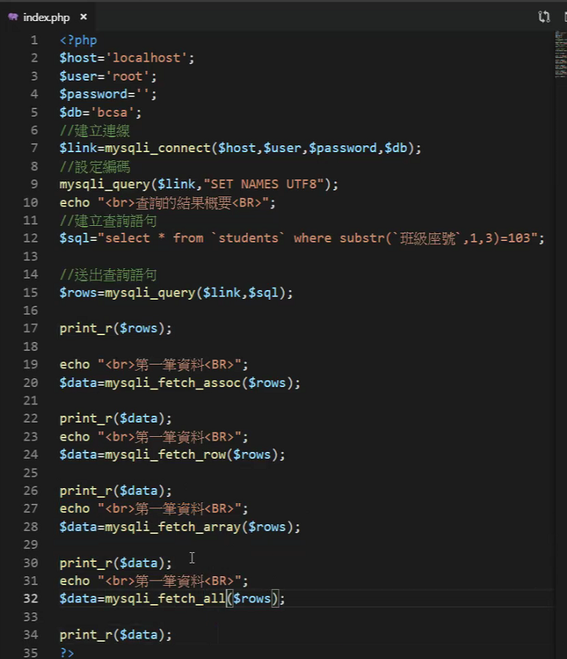

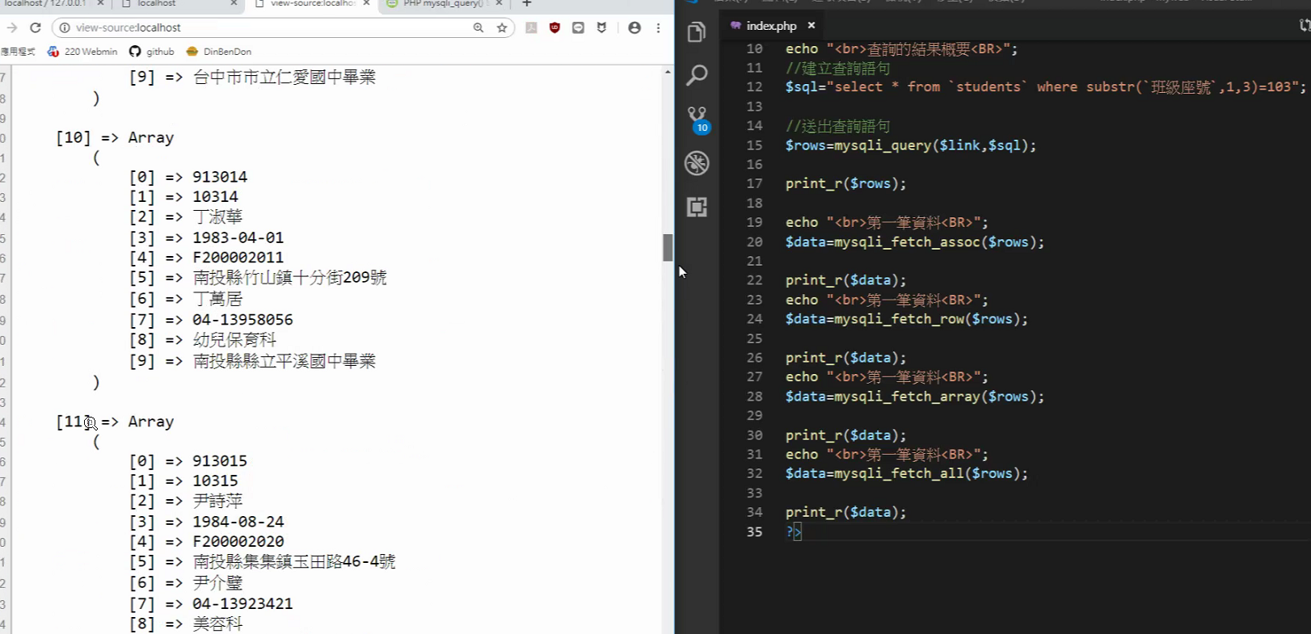

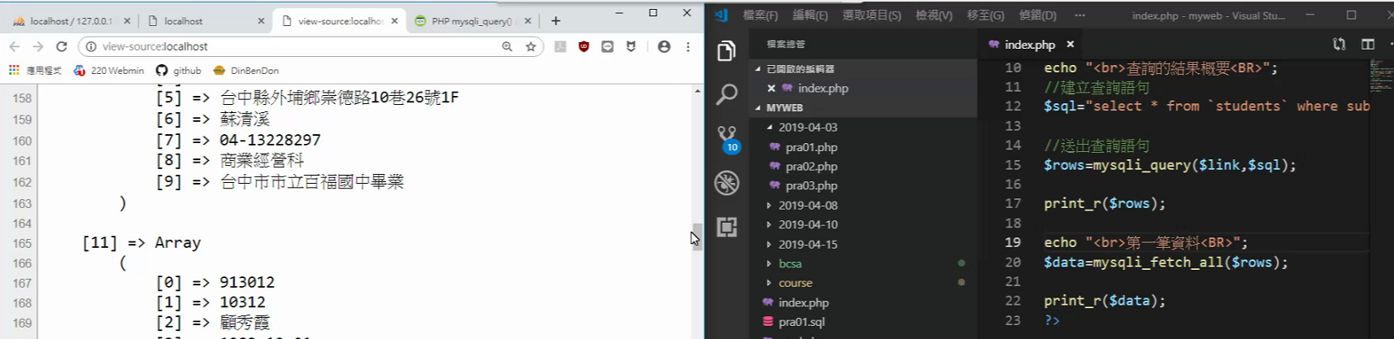

用下面這個方式看結果

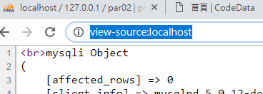

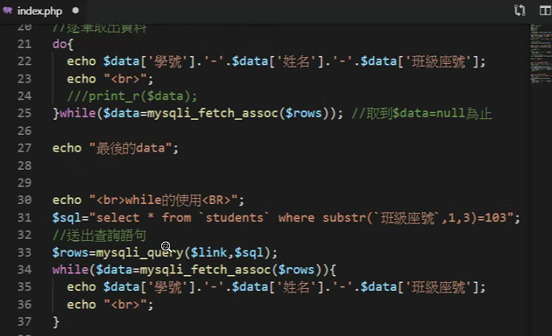

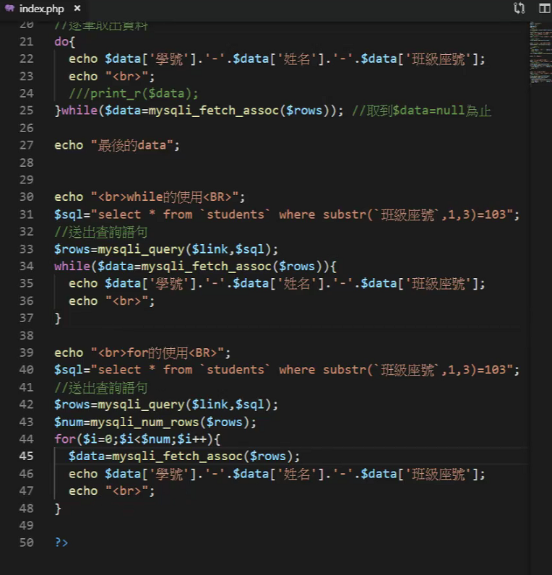

這樣會失敗

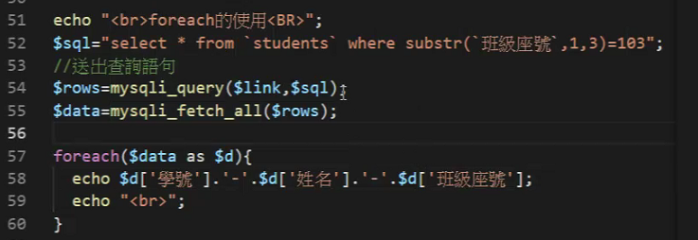

這樣會成功

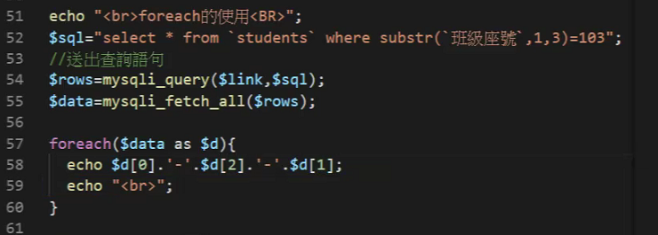

要定義常數,才能用對應欄位名稱

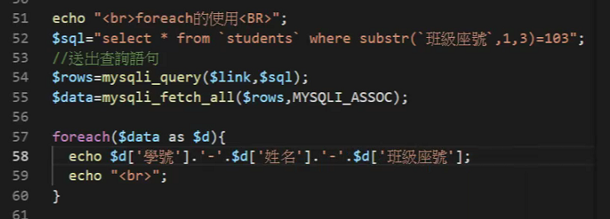

或用MYSQLI_ASSOC_BOTH 兩種都可用

PDO





兩行合併為一行

/* $rows=$pdo->query($sql);

//print_r($rows);

$data=$rows->fetch(); */

$data=$pdo->query($sql)->fetch();

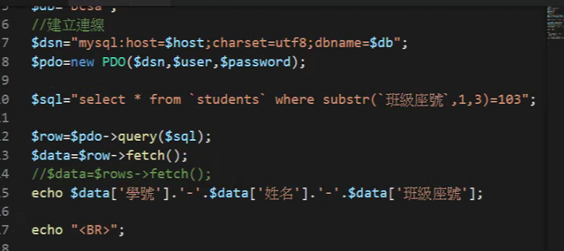

Fetch用法

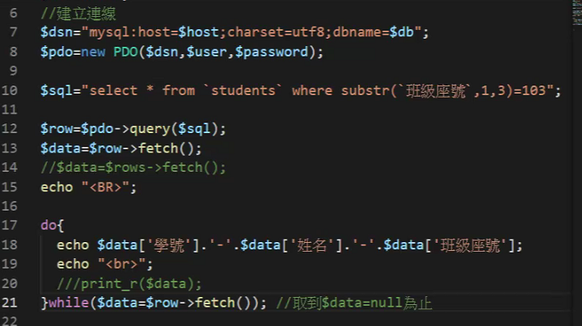

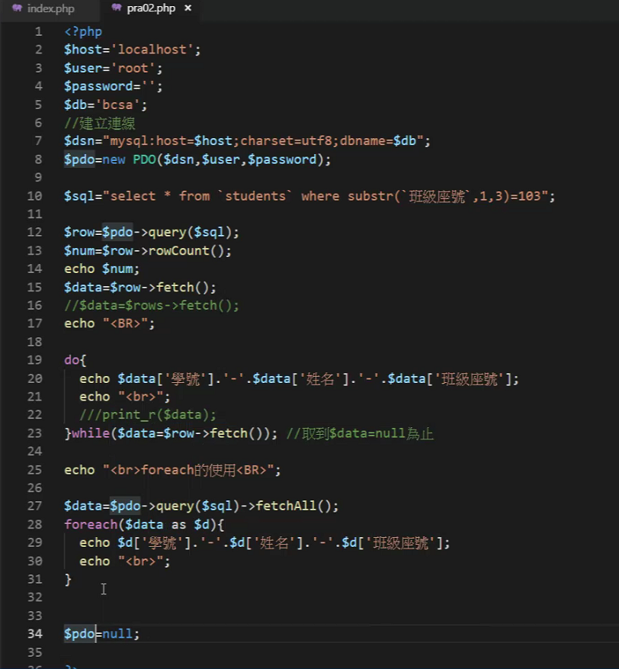

乙級題組一

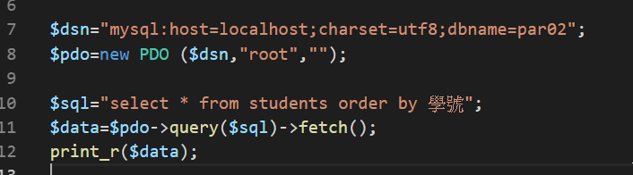

Ctrl+U

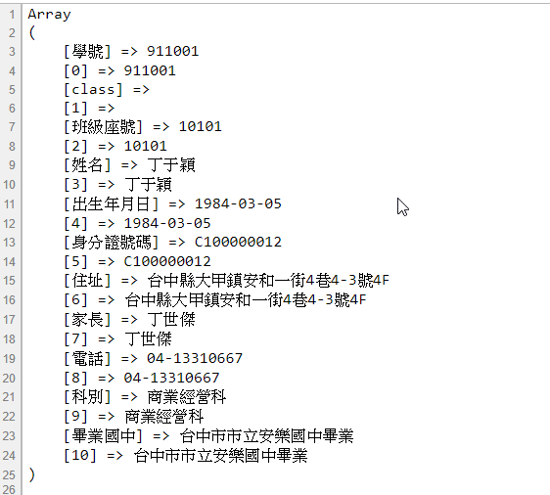

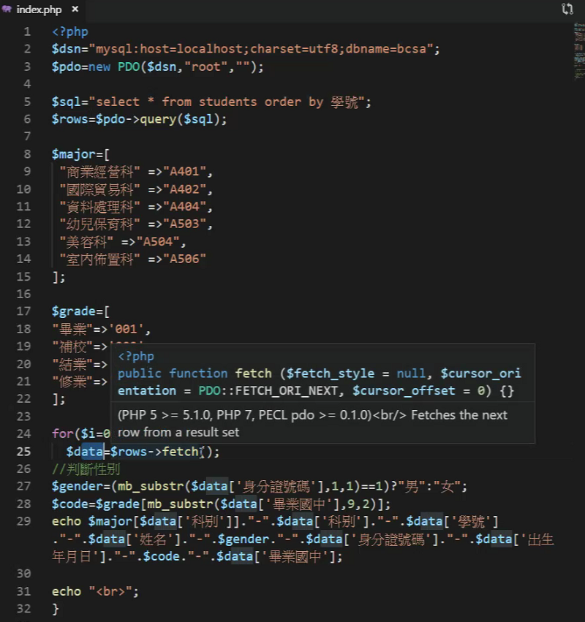

fetchAll() 用法

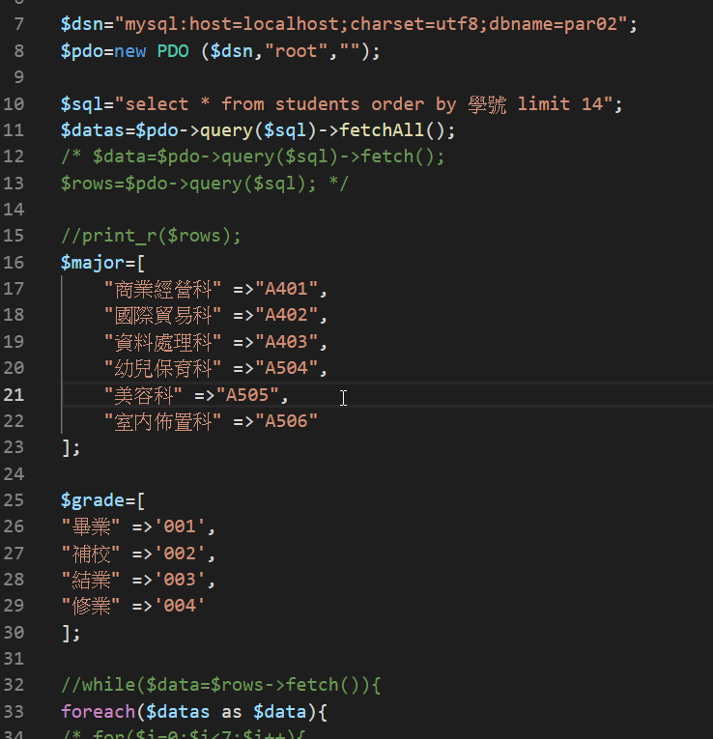

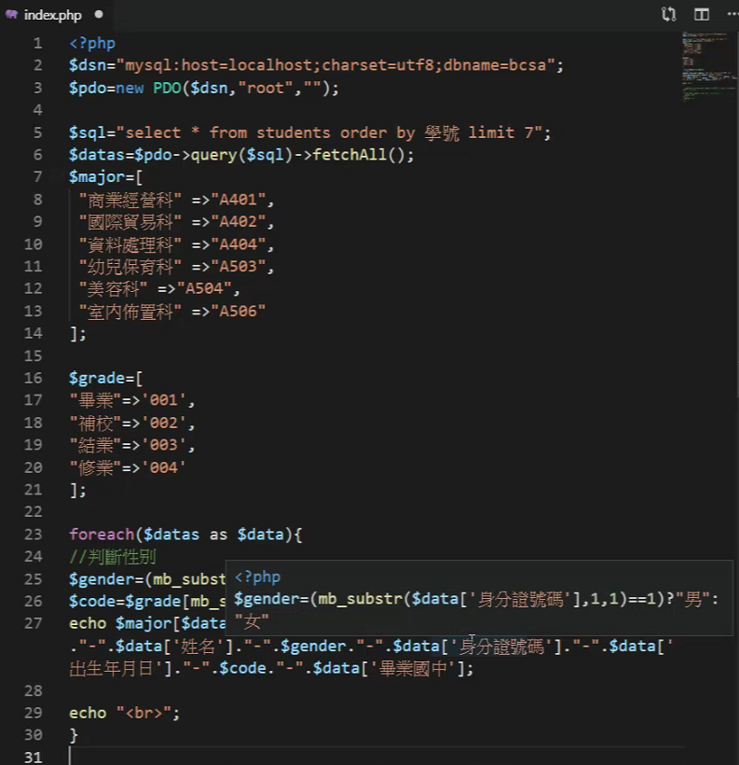

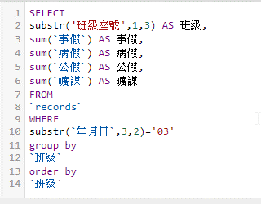

SELECT

substr('班級座號',1,3) AS 班級,

sum(`事假`) AS 事假,

sum(`病假`) AS 病假,

sum(`公假`) AS 公假,

sum(`曠課`) AS 曠課

FROM

`records`

WHERE

substr(`年月日`,3,2)='03'

group by

`班級`

order by

`班級`



SELECT substr(`班級座號`,1,3) AS '班級' ,count(*) FROM students GROUP BY substr(`班級座號`,1,3)



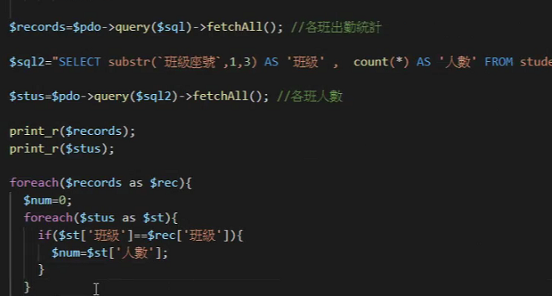

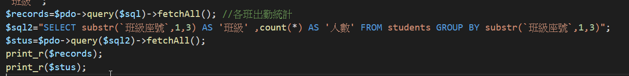

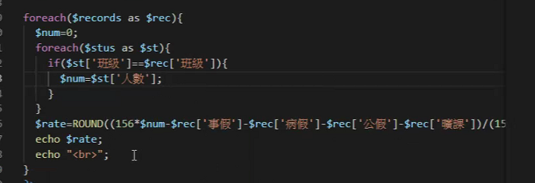

前端要顯示的東西,放到陣列裡面

